## Demo talent search function

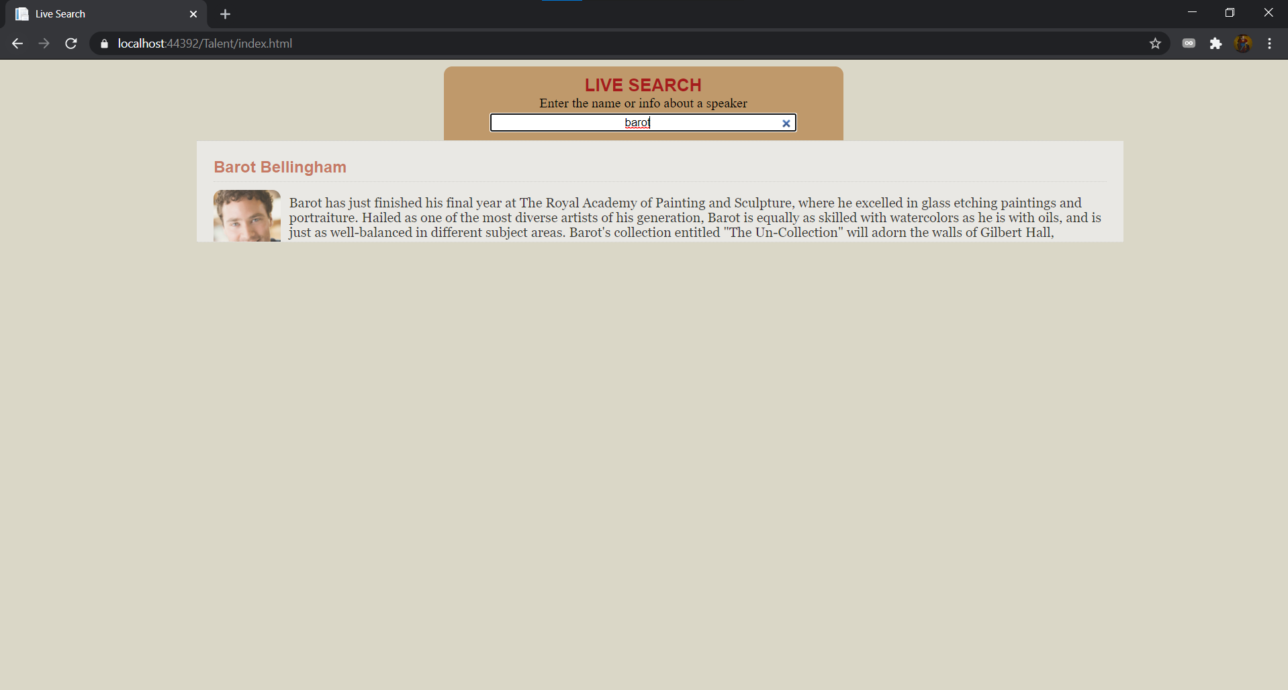

## Demo access to HTTPS secured talent search

## Web API document

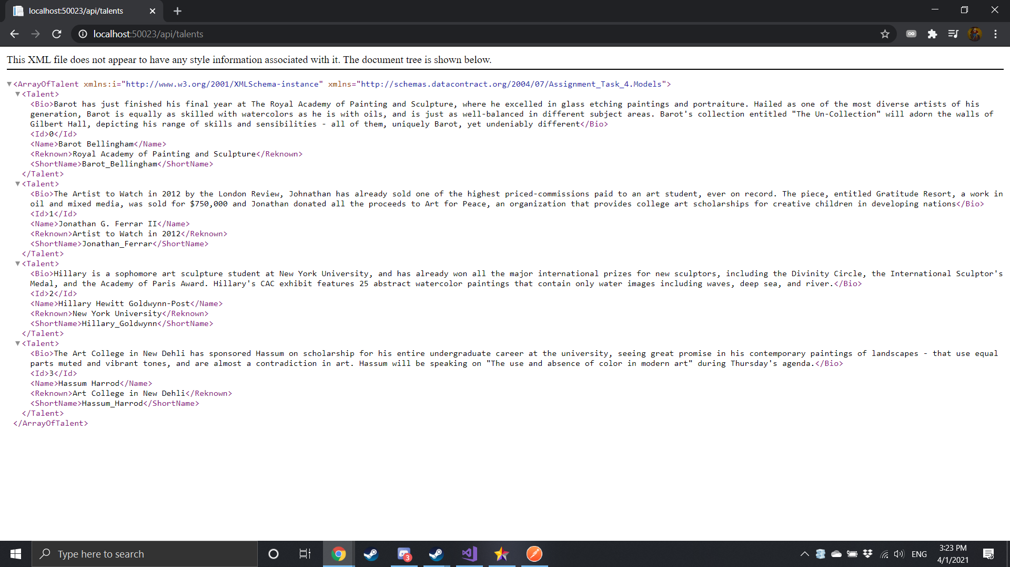

## Postman testing result

### HttpMethod:Get

Route:api/talents

Description:Get all talents

URI Parameters:None

Body Parameters: None

HttpResponseStatusCode:200 OK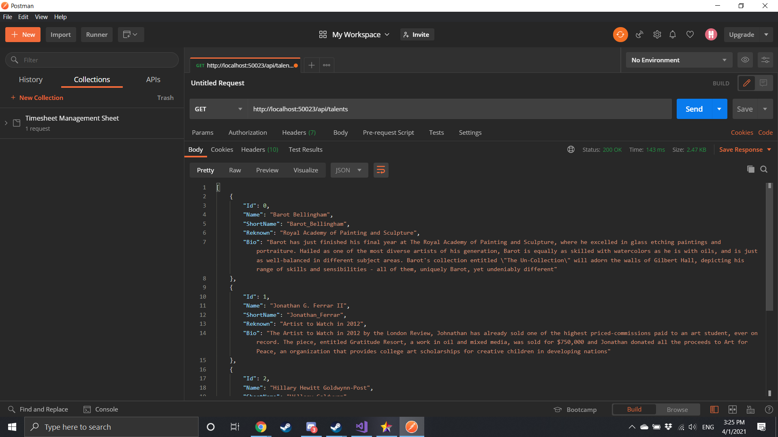

Route:api/talents/{id}

Description:Get talent by id

URI Parameters:id

Body Parameters: None

HttpResponseStatusCode:200 OK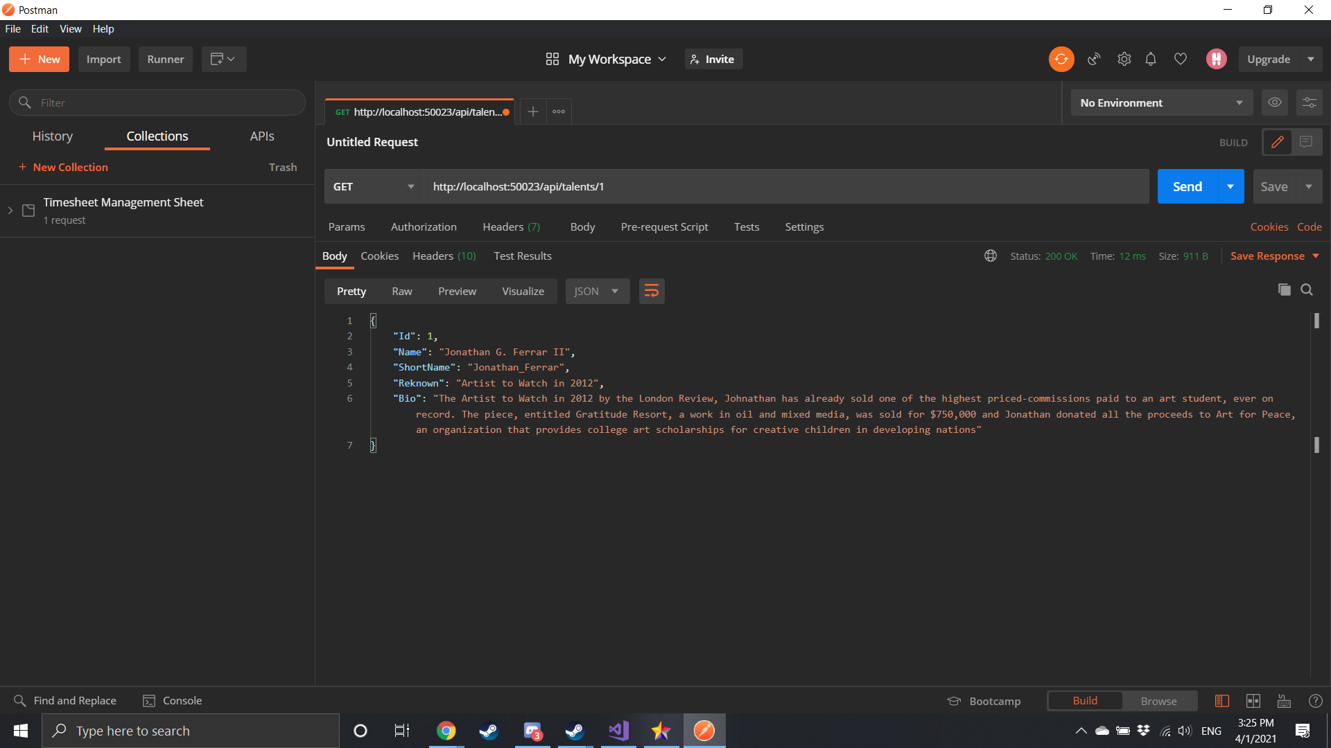

## 

## 

## Draw a sequence diagram to explain your understanding